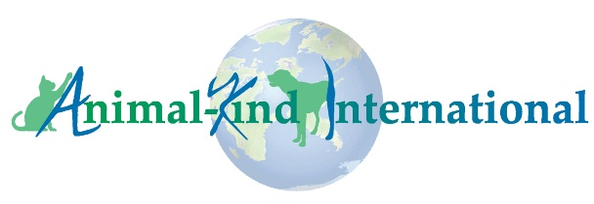
Animal-Kind International

Africa-Based Animal Welfare Organization Grant Guidelines

AKI Background
Animal-Kind International is a US-based organization that raises funds for Animal Welfare, Rescue, and Protection Organizations in resource-poor countries. We support our Partner Organizations and our funding typically covers the costs to operate shelters/sanctuaries for cats and dogs, community animal care clinics, street cat and dog care, spay/neuter programs, programs for working and abandoned donkeys and horses, and humane education in schools and communities.

Grant Program Funding Requirements
AKI’s 2022 Africa-Based Animal Welfare Organization Grant Program, AKI’s 5th annual grant program, is intended to assist worthy Africa-based organizations, beyond our Partner Organizations, capable of implementing high impact projects aimed at improving the lives of domestic animals. AKI will only consider funding for:
- Projects that benefit cats, dogs, donkeys, and/or horses (secondarily, we will consider projects that benefit cattle, goats, sheep, chickens, and pigs).
- Existing organizations based in Africa that have been operating in the animal welfare sector for at least 3 years.
- Organizations that are currently and actively engaged in their communities to improve the lives of animals.
- Projects that can be completed within 6 months of receipt of funds.
- Projects that demonstrate sustainability and that give assurance the efforts will continue beyond the grant period.

Grantee Reporting
Grantees are required to:
- Submit Monthly & Final Grant Reports – Monthly Grant Reports and a Final Grant Report are required of all grant recipients. If your proposal is successful, we will provide you with the report template. Applicants to our grant program must identify an individual responsible for the reports. That person must have the capacity to write, in English, a detailed, accurate report with pictures and receipts, as required in the template.
- Post information about their AKI grant project on their website and on social media sites – Our Grant Program is fully funded by donations from individuals. Posts on your website and social media pages help raise awareness of our Grant Program, helping to ensure that the program will continue in subsequent years, and ultimately, making more funding available to Africa-Based Animal Welfare Organizations. If you are awarded an AKI grant, the Grant Agreement will include specific requirements for posting on your website and social media pages.

Prohibited Use of Funding
Recipients agree to use grant funds only for activities that directly benefit animals and to not use grant funds for the following:
- Website development
- Capacity building, professional development, and workshops for staff
- Debt reduction
- Political activities
- Religious activities that do not directly benefit animals
- Activities that do not implement covid-19 best practices, where and when required

