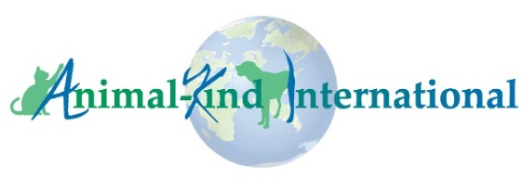
Animal-Kind International

Africa-Based Animal Welfare Organization Grant Program FAQs

Q: Who can apply for a grant?
Any organization that is based in Africa and has been operating for at least 3 years in the animal welfare sector, is registered as an NGO, non-profit, or similar, in their country of operation, and whose main goal is to improve the lives of domestic animals in their community. To apply, your organization must be in good standing (all required government documentation must be in compliance with national laws and must be up to date).

Q: How can an organization apply?
Organizations interested in applying for an AKI grant should submit a complete grant application between May 22 and June 15, 2022 (midnight GMT deadline). We will not accept proposals prior to May 22, 2022. To be considered eligible for consideration, all required documentation must be received by midnight GMT on June 15, 2022. AKI will only review complete submissions. Applications and supporting documentation received after the deadline will not be considered during this grant cycle. Complete applications should be sent to karen@animal-kind.org. We will acknowledge receipt of all proposals.

Q: Do you accept photos and videos as part of a proposal application?
We accept photos only, but they should be specific to the proposed project and they must be well-labelled and sent as jpeg email attachments. Photos will not be considered as a substitute for a well-conceived written proposal and should be used only to support the written application.

Q: Do you fund projects in the U.S. Asia, or other regions?
No. We only accept grant applications for projects from Africa-based organizations, not from organizations based in countries outside of Africa.

Q: How much are grants?
For previous grantees who have successfully completed their AKI-funded grant, the budget ceiling is US$3000. For those who have not received an AKI grant previously, the ceiling is US$2000. However, we have a limited budget for our grant program, and we want to award as many grants as possible, so please keep that in mind when developing your proposal and budget. Rather than automatically submitting a budget for the maximum amount, submit a cost-effective and impactful proposal --and then budget for that.

Q: Our organization previously received an AKI grant. When can we apply again?
Previous grantees are free to apply each year as long as they have completed their previous grant, including all reporting.

Q: How will grantees receive funds?
Once we notify you of the award, we will discuss with you the best method of transferring funds to your organization.

Q: How long does the grant application process take?
Grant applications are due no later than June 15, 2022. We will announce grant awards on/about August 1, 2022. Organizations should be prepared to begin the project in time to complete it within 6 months from the date funds are received.

