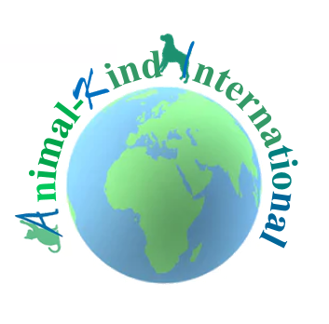
Animal-Kind International

Grant Application for Africa-Based Animal Welfare Organizations

Date:

Organization Name:

CONTACT INFORMATION

Contact Name (Your Name & Your Role in the Organization):

E-mail Address, Phone Number (with country code), Website, Facebook page, other social media pages

Organization Street Address:

Mailing Address:
If different

If a grant is awarded, who in your organization will be responsible for monthly reporting to AKI? (Name & Role in the Organization):

ORGANIZATION INFORMATION

Founding Date & Registration Status of Organization (Is the organization registered as an NGO, non-profit, etc.; include registration number):

Organization’s Mission Statement, Goals, Objectives, and Primary Activities (including primary operating locations-county, city, village, etc.):

Number & Titles of Paid Employees & of Key Uncompensated Volunteers in the Organization (note whether paid or unpaid):

Has your organization received financial assistance from any foundations or organizations in the past 3 years? If so, please provide the organization/foundation name, title/type of projects supported, start/end date of projects supported, the amount in US$, and how the funds were used:

Please attach your organization’s 2019/2020 budget (income/expenditures) when you submit this application.

PROPOSAL INFORMATION
Please explain your proposed project in detail, including the purpose, the steps involved in implementing the project, and the proposed timeline-the project must be completed within 6 months of receipt of funds (if needed, please add more lines). Photos and videos may be submitted with the proposal to help illustrate the proposed project’s need and methodology (they should be well-labelled and sent as jpeg attachments, not embedded in the application):

Have you requested funds from elsewhere for this project? If yes, from where, for what amount?

Will this grant cover the full cost of the proposal? If not, please describe the additional needs.

Please provide a detailed budget for this project using the template below or similar and please provide a budget narrative in the lines below (add more lines, if needed). Please ensure your project budget is within AKI’s budget range for this grant program.

Proposed Budget (in US$)
Item | Cost/Unit | # of Units | Total

Budget Narrative (please provide more explanation for costs below and describe how costs have been determined and calculated):

SUBMISSION INFORMATION
NEW: PLEASE SEE THE ANNEX FOR INFORMATION ABOUT COVID-19 INFORMATION & COMPLIANCE
To submit your completed grant application, please email it as an attachment to karen@animal-kind.org with email subject line, AKI Grant Program. Please submit only one application/organization.

APPLICATION PROCESS
Animal-Kind International will accept grant applications from June 1 through July 15, 2020. Any application that arrives after midnight on July 15, 2020 (US Eastern Time) will not be considered. We will review applications between July 15-July 31, 2020, and we will announce the 2020 winning grantees during or soon after the 1st week of August. During the review process, we may contact you for additional information and we may request letters of reference in support of your organization and/or the project. Please make sure someone from your organization is available during our review period to respond to questions. An AKI Board Member will contact you after the review period to inform you of our decision to approve or decline funding.

TERMS & CONDITIONS
Grant Guidelines & FAQs:
https://www.animal-kind.org/grant-program
Today’s Date:
Printed Name & Title:
Signature (e-signature or typed is acceptable):
By completing this application, you fully agree to adhere to AKI’s Grant Guidelines (see link above), including the submission of required reports and financial documentation.

Animal-Kind International
PO Box 300
Jemez Springs, NM 87025 USA
Phone: 575-834-0908
www.animal-kind.org
For questions, please send an email to karen@animal-kind.org
ANNEX: COVID-19 INFORMATION & COMPLIANCE
(1) Please describe safeguards that you will put in place and how your proposal is compliant with your country’s and WHO regulations, guidance, and recommendations.

(2) Given that we don’t know what the covid-19 situation will be when we award grant funds, please describe the process you will implement, if necessary, to adapt your proposal and how flexibility is built into the design and implementation to ensure it is compliant with covid-19 best practices.

